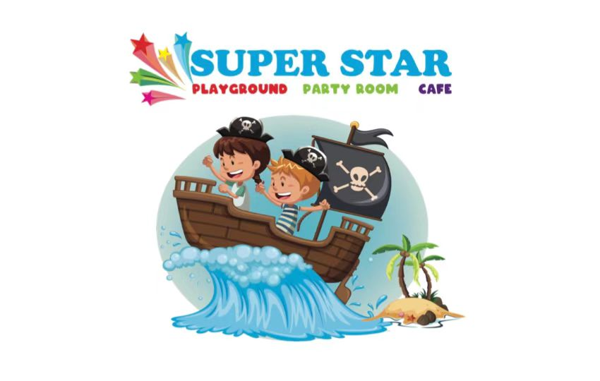
Food Waiver

I ________________________, booked at Super Star Playground, declare:

In consideration of being permitted to bring in outside food for
Party / Private Function on _________________(date), I assume all risk of personal allergies, injury or illness arising out of or resulting from consumption of food items provided by myself and discharge Superstar Playground from any and all claims, liabilities,damages, losses, or other expenses of any nature arising out of or resulting from the consumption of the food items provided by myself.

The food will be consumed in the following area : Party Room

Name: ___________________________
Signature: ________________________
Date: ____________________________

